AI Movie Recommender System Design Document
Layout
Title, authors and reviewers
Functional description
User interface
Goals and milestones
Prioritization
Current and proposed solutions
Timeline
Functional Description
The system will be able to do the following once fully build, implemented and deployed successively:
Allow user requests and display the requests being made. This will enable simple tracing and followups in case of errors and any complaints.
Support input search auto-complete feature. This feature will minimize typing errors and also increases the searching speed since one won’t have to input the whole title if it already exists in the system.
Fetch the connection between the title keyed in the search bar and the ones in the datasets provided to it. Carry this out using the genre, title, directors, casts (actors), rating e.g. IMDB rating, and year among many other factors.
Display the fetched results so that the user can easily choose their preference.
In case of any errors, handle them with ease but also inform the end user on how to proceed from them.
Display additional information on the movie searched for such as reviewer comments which will help the user determine if the movie is appropriate for them.

User Interface
The following will have to be considered when building the site’s user interface:
Consistency in design and color selections
Simplicity in design
Minimizing of errors
Error handling and user friendliness
Minimalism of the sites content to reduce excessive use of long term memories especially for old users since it can be stressful for them.

User Interface Design
The application will contain two main webpages, these are the:
Landing webpage
Results webpage

The contents of these webpages are as discussed below:

Landing Webpage

This is also known as the main webpage since by default the application will use it as the landing page.
It shall contain the search bar which allows one to key in searches for the system to take in as input. It shall display autocompleted titles if they exist and are related to the search. One can click on them for quick autocomplete feature.
It also displays errors such as if the system lacks the searched movie title.

It shall appear as shown below:
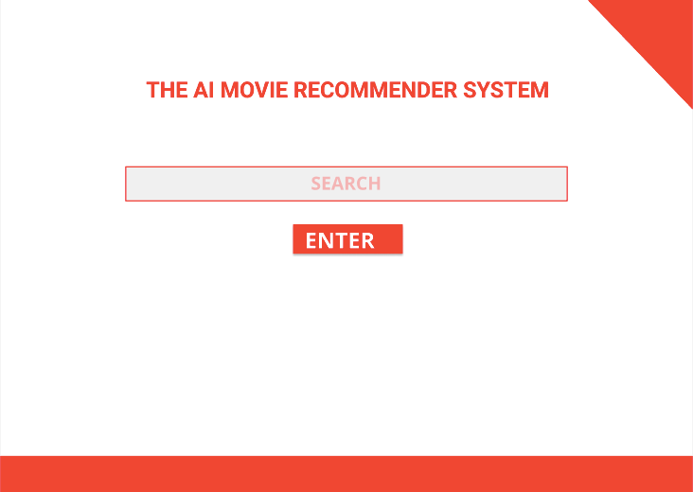
The site will display the following incase of any errors such as non existent searches:
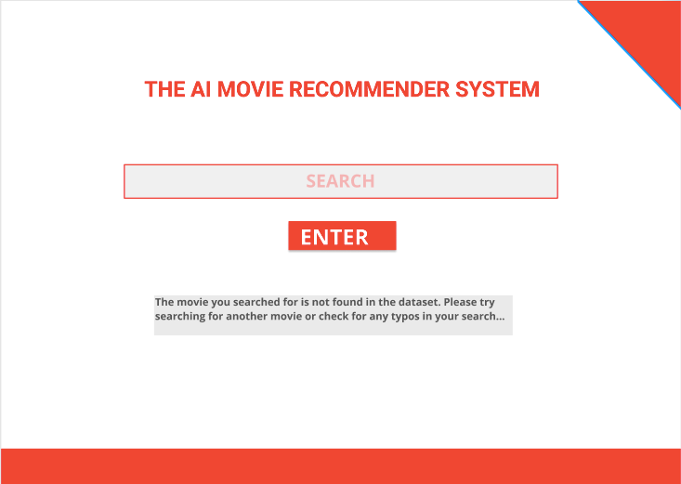
Whenever the user runs a succesful search, the application will display the searched for movie, its descriptions, reviews, and recommendations among other things. The design of this is shown in the image below:

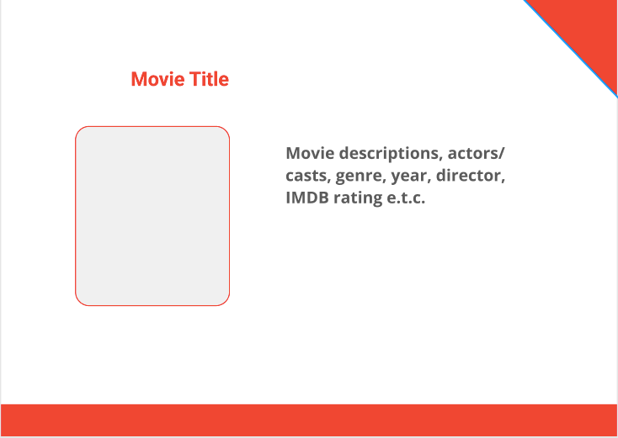
Goals and Milestones
The following achievements will be able to show progression of the application development process:
Creation of the Landing page and Results page web templates which will be used to generate static webpages that will have the fetched data in them
Create the Search Autocomplete feature
Create a connection between the application with the online dataset provided using the API and the API_KEY for recent and updated results
Create the AI engine to evaluate the datasets and display the results to best fit.
Document the system
Do tests using various data
Correct any minor errors and rerun tests
Do installations and deployments

Timeline
The project will take approximately Three months (3 months) to be completed.
The time will be splitted as follows:

